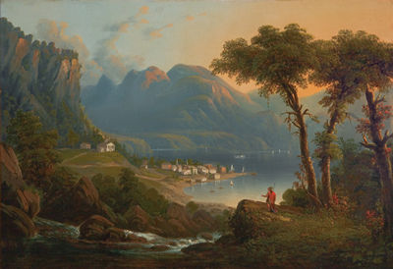
Highlands Historic Preservation
A Non-Profit Organization Dedicated to Preserving the Highlands’ Hidden Historic Resources
Kent Lakes, NY 10512
(845) 249-8880
www.HighlandsPreservation.org
Visit us on Facebook

December 8, 2016

Highlands Preservation Chairman Tom Maxson addressed the Town of Kent Planning Board as part of a public hearing regarding a proposed residential project along Maynard Road in Kent.

Tom Maxson provided details as to the continued status of Maynard Road as a Kent town road. As per the New York State Department of Transporation listing of town roads in Kent, Maynard Road extends .29 miles beyond the end of Beach Court.

Official maps of the town throughout the 1800s and 1900s showed the existence of this road. And as is true for many of the early roads, it was most likely originally a Native footpath to and from Mount Nimham, a sacred place to the indigenous people, and Pine Pond. The historic farm of the Revolutionary War patriot Samuel Hawkins, later owned by Civil War veteran Isaac Parker, and later by beloved citizen Harry Maynard, is found along this road. It contains a root cellar/ice house (known generically as a “stone chamber”), a large barn foundation, well, and other remnants exist there today.

According to the Cornell University Local Roads Program, this ownership right is unchanged regardless of the ownership of the land surrounding the road. The adage, "once a highway, always a highway" has been used to reflect the legal status of these public thoroughfares. There is a presumption in New York State as to the continuance of a public highway.

The only way in which a town may waive its right to a public road is through a formal "abandonment" process, as described in the Highway Law. This is an affirmative act of the public authority having jurisdiction over the highway. This process requires:

- Formal recommendation by the Highway Superintendent;
- Written notice of the pending abandonment proceeding served on all affected property owners;
- A public hearing;
- A public vote and approval by the Town Board.

Maxson had asked the Kent Town Clerk on several occassions in the past 10 years to search town records for any Town Board resolutions formally abandoning Maynard Road, and none were found. Therefore, it is presumed to remain as a town road. The NYS DOT listing confirms that.

This designation is important for several reasons. First, emergency vehicles may occassionally need access to this area in response to fires and other emergencies. Second, the historic farm site is accessed by this road. And third, local residents have used the road for many years for horse riding and hiking to the farm and the fire tower at the top of the mountain.

The Kent Planning Board agreed, and declared that the public right of use will continue, even though there is a private property owner on either side of the road near Beach Court.

