Preserving the Past
By Tom Maxson

The Fishkill Supply Depot and Encampment

One of the most significant Revolutionary War historical sites lies across the border from Putnam County in the town of Fishkill.

The Fishkill Supply Depot and Encampment, located on what was the Albany Post Road, or Route 9 today, was where the patriots kept their material and supplies needed to maintain the Continental Army’s ability to fight the British. The King’s forces were intent on securing the North River (Hudson River), thus severing and dividing the colonies and breaking their chain of supplies and support. The Depot was established on the orders of General George Washington in 1776, who was a frequent visitor throughout the war years. It was instrumental in assisting the patriot forces in their victory at Saratoga in 1779, which was considered a turning point in the eventual American victory in 1783.

As described in 1850 by Benson J. Lossing, in his “Pictorial Field Book of the Revolution”, “Securely sheltered by high mountains from invasion from below, and surrounded by a fertile country, it (Fishkill) was chosen as a place of safe depository for military stores; for the confinement of Tory prisoners and others captured by strategy or in partisan skirmishes upon the Neutral Ground, in West Chester; and, for a while, as the place of encampment of a portion of the Continental Army, and the quiet deliberations of the state Legislature.”

In 1732, Cornelius Van Wyck (1694–1761), a surveyor, built a house with three rooms, which was later expanded. During the war, it was requisitioned by the Continental Army to serve as Gen. Israel Putnam’s headquarters. It was made famous by the exploits of “The Spy”, as per the James Fenimore Cooper story, who was actually Enoch Crosby. In addition to George Washington, it was a destination for the Marquis de Lafayette, Friedrich Wilhelm von Steuben, Alexander McDougall, Alexander Hamilton, and John Jay.
According to Philip H. Smith’s “General History of Dutchess County from 1609 to 1876” (1877), “Large quantities of stores from Dutchess and adjacent counties, as well as from the eastern States, were there accumulated for the use of the Continental army. They (the barracks) were located on the level plateau southeast of Fishkill village. Frequently, large bodies of troops were stationed there. After the battle of White Plains the wounded were conveyed to Fishkill where, in addition to the barracks hospitals, the churches were used for that purpose. Of the many that died, it is asserted, their bodies were piled up as high as cord wood in places between the Dutch and Episcopal churches. Near the base of the mountain a short distance south of the village is the soldiers’ burial ground, where moulder the remains of hundreds of patriots, whose devotion and blood helped to secure the inestimable boon of liberty. Small-pox, which broke out in the camp, added the bodies of many more.”
On October 14, 1897, the “Continental Soldier’s Monument” was dedicated at the burial ground by the Melzingah Chapter of the DAR, but it was later moved near the house.
The remaining 70 acres of the Fishkill Supply Depot was added to the National Register of Historic Places on January 21, 1974. Over the years, the site has been threatened by a number of projects, including the building of I-84, the construction of the Dutchess Mall in 1974, a gas station, and several stores.
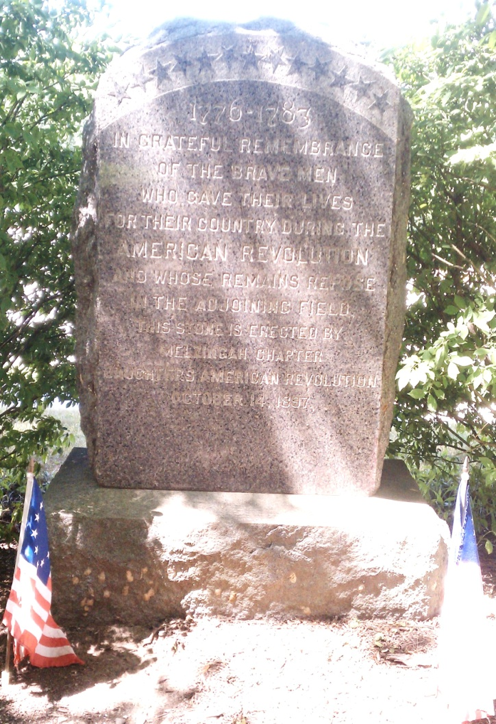
An archeological report released in 2009, using ground penetrating radar, identified hundreds of likely grave sites on the southern end of the property, consistent with the historical narratives.
This was the most important northern supply center during the Revolution, including a burial site of at least 300 patriots in unmarked graves, if not more. Unfortunately, other than the Van Wyck house itself, no other notable structure survived, even though there was once a sprawling military complex here, including more than 10 storage buildings, a prison, hospital, blacksmiths, bakeries, stables and workshops to supply the troops. And while the one winter spent at Valley Forge is indelibly preserved with a national park, the Fishkill Supply Depot’s critical role throughout the war years has been greatly overlooked.
DAR’s Continental Soldiers’ Monument (Tom Maxson)
Today, the latest threat is a proposed shopping center and small hotel dubbed “Continental Commons”. This 10.47 acre proposal, which only preserves a .25 acre sliver of a burial ground, is being opposed by the Friends of the Fishkill Supply Depot (FOFSD). They are seeking to preserve the Depot so that a comprehensive archaeological study can be performed, fully interpreting the site and burial locations, and including it with the Hudson Highlands State Park Preserve.
It was recently announced that the Town of Fishkill Planning Board will hire an archaeologist while moving forward with the site review for Continental Commons. It is the fervent hope of preservationists that a comprehensive effort will be made to document and preserve this important site, and honor the brave patriots who served, before it is too late.

