Preserving the Past
By Tom Maxson

The Hill Cemetery

Cemeteries are hallowed repositories of our history. They help tell the story of our genealogy, culture, religion, and society.

A great example of this is the Hill Cemetery in Red Mills, located directly on Hill Street south of the Putnam County Golf Course. The patriot Hill family settled on the farm at least as early as 1740, when Anthony Hill, of English descent but born in Holland, purchased it from the local Native people. He and his wife had nine children, including the patriot Captain William Hill (1726-1796) and his brother, Uriah, who passed away in 1765. Anthony Hill sent these two oldest sons to work the farm in 1741.
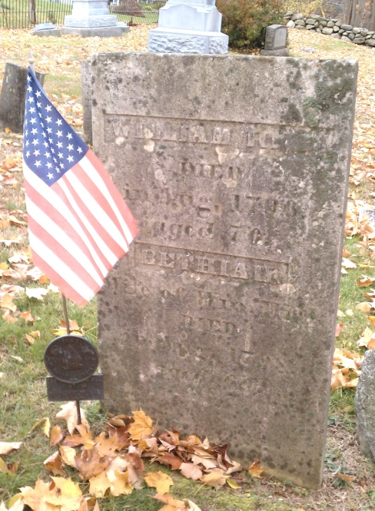
While William flourished on the family homestead, Uriah was deemed to be “obnoxious” by his Native neighbors, and was obliged to leave, per William Blake’s 1849 “History of Putnam County”. William Hill served first as a lieutenant during the French and Indian War, and later as a captain extending through the Revolution.

According to an interesting anecdote shared by Blake, one night William went out looking for a lost calf, and was attacked by some wolves. “By climbing up a tree and remaining on it nearly all night, he escaped from them by a circuit to the north side of Lake Mahopac, where early in the morning he came to the log-house of George Hughson. This was the first he knew of a white man residing there.”

Capt. William Hill (1726-1796) (Tom Maxson)

After the Philipse family disputed Anthony Hill’s original purchase from the Native Americans, William Hill made the first land purchase in Putnam County, from the holdings of Colonel Roger Morris and his wife, Mary Philipse Morris. This was Farm Number 36, located in Lot No. 5 of the Philipse Patent, totaling 245 acres, including the cemetery. The sale was completed on September 25, 1763, for £750.

William married Bethia Smith (1738-1798), the daughter of Abraham Smith of Putnam Valley. They had at least 11 children, including patriot sons Noah (1754-1830), William (1760-1851), and Cornelius (1764-1815), who all served in the Dutchess County Militia.

Following the war and the confiscation of loyalist properties, including Lot No. 5 and the Hill Farm, heirs of the Philipse family pursued legal challenges based upon a clause in the marriage contract between Mary Philipse and her to-be husband, Col. Roger Morris, in 1758. That clause stated that only their children could inherit their property, and upon the death of Mary Philipse Morris in 1825, that clause was invoked. Recognizing an opportunity, in 1809 John Jacob Astor had purchased the land rights from her descendants for $100,000. After years of litigation, including appeals to the Supreme Court under Chief Justice John Marshall, Astor accepted a payment of $450,000 in 1832 from New York State to drop his case. But this case helped define the scope and breadth of the Court’s power of judicial review under the Constitution, which remains today.

The original house, which was located just north of the cemetery, was torn down around 1843. The current house, located a bit to the west of the original dwelling, was built about that time. It is a great example of Greek Revival-style architecture.

According to Pelletreau’s 1886 “History of Putnam County, New York”, “Capt. William Hill divided this farm among four of his sons; the south part, containing 98 acres, he gave to Abraham, whose heirs sold it to Thomas Hill. At the time when Anthony Hoguet and his associates were anxious to buy, Hoguet's Point in Lake Mahopac, of Abijah Smith, he refused to sell unless they would buy him this farm in its place. Accordingly, the arrangement was made, and Thomas Hill sold it to Abijah Smith September 15th, 1854, and he lived on it till the time of his death, when it fell to his only child, Sarah, who married Peter B. Curry, 2d. Their only surviving child, Sarah A., married Kelsey Agor, and they are now the owners of this part, of the original ‘Hill Farm’."

Putnam County purchased the remaining 23-acre Hill-Agor Farm, the old Mahopac Airport property, and the adjacent golf course in 2003. After New York State designated the farm as being eligible for placement on the National Register of Historic Places in 2005, which would allow for preservation grant funding, efforts continue to obtain the County’s permission to proceed.

The Hill Cemetery is one of the many cemeteries whose maintenance is overseen by the Putnam County Historic Cemetery Committee, headed by Cathy Wargas, and overseen by County Historian Sarah Johnson. Each town is represented on the Committee, with Mike Troy, former Carmel Town Historian Brian Vangor, and Allan Warnecke, the former Putnam County and former Town of Carmel Historian, representing the town of Carmel, where the Hill Cemetery is located. The Committee also created and maintains a wonderful website, “putnamgraveyards.com”, where a wealth of information can be found.

