Preserving the Past
By Tom Maxson

Wilma Baker, A True Preservationist

The town of Kent, and Putnam County, lost a beacon of preservation and good works with the passing of Wilma Baker on February 28th.

Wilma Minnie Kuhlenschmidt was born on March 19, 1925 in Elberfield, Indiana. On June 7th, 1947, she married the love of her life, James E. Baker. They later took up residence in the old 18th century tenant house that was once part of the Nichols farm in Kent, in 1961. As they raised their family, they immediately immersed themselves in the fabric of our community. Wilma and a group of other dedicated volunteers worked tirelessly to found the Kent Literary Association in 1963, after engaging in a series of meetings, fund raisers, membership drives, petition and letter writing campaigns, to help bring a library to Kent.

Per the website of the Kent Public Library, “The first Kent Public Reading Room was a part of Edna Stadler’s Curio Shop in Lake Carmel on Chauncey Road and moved to share a building with Gladys Boalt’s Fabric and Crafts Shop on Smadbeck Road (now Rt. 52). On May 25, 1967, the association was granted a provisional charter by the Education Department of the State of New York as the Kent Free Public Library. The library purchased the other half of the building on Smadbeck Road on August 24, 1972.” Wilma continued to serve on the board of the Friends of the Kent Library for many years.

Wilma was also a co-founder of PLAN-Kent, an organization born out of the threat of a SLAPP (“Strategic Lawsuit Against Public Participation”) lawsuit filed by a local developer in order to intimidate and silence the Bakers. This organization later went on to help fund the restoration of the historic Mount Nimham fire tower, with Wilma leading the fund raising effort. PLAN–Kent has also been involved in supporting other worthy efforts and organizations, including Arts on the Lake.

Wilma and Jim also helped found the Kent Recycling Center (KRC) in 1992. This model of volunteerism helped the beleaguered residents of Kent deal with the exorbitant private garbage collection fees, and allowed them to recycle to an extent never seen before. The list of recyclable materials is a very extensive one at the KRC, lessening the amount of garbage needed to be thrown away and added to the landfills. And even those who did not use the center have benefitted, thanks to the competition they created with the private carters, helping to lower those rates over the years.

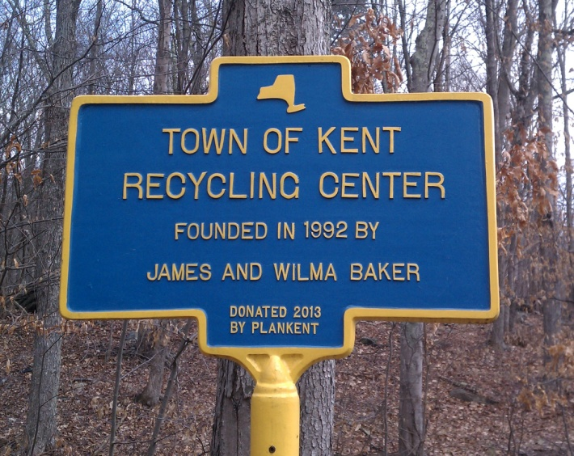
The KRC started by using the parking lot of the Kent Cliffs firehouse, where they and the devoted volunteers, including Kathy Freston and Howard Carpenter, set up and took down the operation every Saturday. They later moved to the old town dump on Ressique Street, until finally finding their permanent home on Route 52 adjacent to the Kent Town Complex. Despite the rain, snow, wind, and freezing or stifling temperatures, Wilma was there with a smile on her face and a cookie for the little ones.
KRC Historical Marker (Tom Maxson)

Thanks to her and the other wonderful volunteers, the KRC became a de facto community center, to meet up with friends and neighbors every Saturday morning. While Jim continues to assist the KRC patrons every week, and serves as KRC Commission Member Emeritus, the Bakers helped to attract a number of great volunteers who continue to keep the KRC moving forward, including Sue Kotzur and Howard Carpenter, who now serve as KRC co-chairpersons. Some of the other wonderful volunteers include Ines Petterson, Bob Schwaiger, Paul Wilhelm, Janet Barnard, Barbara Mikucki, and many others.

Wilma was a devoted advocate for the preservation of our natural and historic resources. My own interest in local history and preservation was sparked by the hikes led by Jim and Wilma, starting in the late 1980s, to local landmarks like Hawk Rock and the fire tower. Her disdain for vandalism, and their infectious love of nature and history, affected so many others like me as well.

Wilma Baker was also known for taking on the special interests, and the corruption that comes from mixing money and politics. She was a fixture at town board and county legislative meetings over the years, always advocating for the taxpayer and the little guy.

But what I will miss most is her beautiful smile, and adoring looks at her beloved husband. Whenever Jim would tell one of his fabulous stories, which she had heard countless times before, she would gaze adoringly at him as if it were the very first time she was hearing it.

Wilma is survived by her devoted husband, their five children, six grandchildren, and a sister. Her good works in our community will live on forever.

