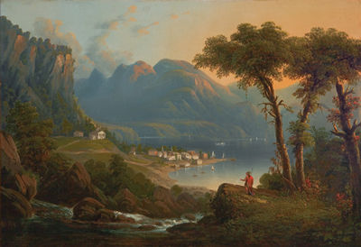
Highlands Preservation
A Non-Profit Organization Dedicated to Preserving the Highlands’ Hidden Historic Resources
103 Whangtown Road
Kent Lakes, NY 10512
(845) 249-8880
www.HighlandsPreservation.org
Visit us on Facebook

December 17, 2014

Victory! New York State Bans Fracking

In a huge victory to protect our air, water, and communities from the toxic dangers of fracking, today the Health and Environmental Protection Commissioners in New York State announced that they would recommend a fracking ban in New York State. Governor Cuomo has stated that he will abide by the science, and the science has spoken.

This “David vs. Goliath” battle between the grassroots opposition to fracking, and the gargantuan energy industry who spent hundreds of millions to promote fracking, took over six years to come to fruition. The money interests pulled out all the stops, including having their spokespersons plant letters and facebook comments everywhere they possibly could.

But the people stood up and made their voices clear. The fracking process involves the injection of hundreds of toxic and carcinogenic chemicals into the ground to force the fracturing of the shale rock to release the trapped natural gas. The drillers are exempted from disclosing what chemicals are being used. In addition, the wells emit tremendous amounts of methane, the most dangerous climate change agent, into the atmosphere. It has been determined that fracking causes earthquakes, and releases radioactive materials into the water supply.

Property owners in PA, OH, CO, TX, and CA have complained about their wells being contaminated, their pets and livestock dying off, and their children developing dangerous illnesses far beyond the normal rates of such occurrences. Most property owners cannot speak publicly of their concerns due to the widespread use of non-disclosure agreements with the drillers.
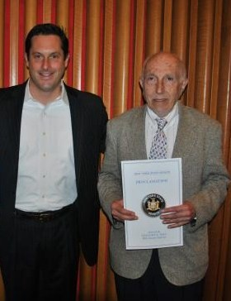
Locally, fracking supporters include disgraced State Senator Greg Ball, “reefer madness” Assemblyman Steve Katz, and some phony hypocrites who are best described as the environmental “wolves in sheep’s clothing”. Many of these supporters have various financial ties to the chemical and energy industries that profit from fracking.

After submitting scores of comments to the DEC and Health Departments, letters and articles in the local media, signing and spreading petitions, and participating in demonstrations against fracking, we at Highlands Preservation are grateful to our State Greg Ball & “Dr. Frackenstein” officials, and want to especially thank DEC Commissioner
Martens, Acting Health Commissioner Zucker, Governor Cuomo, and State Senator Terry Gipson for their common sense approach in protecting our health and safety. History will judge them all very favorably!

