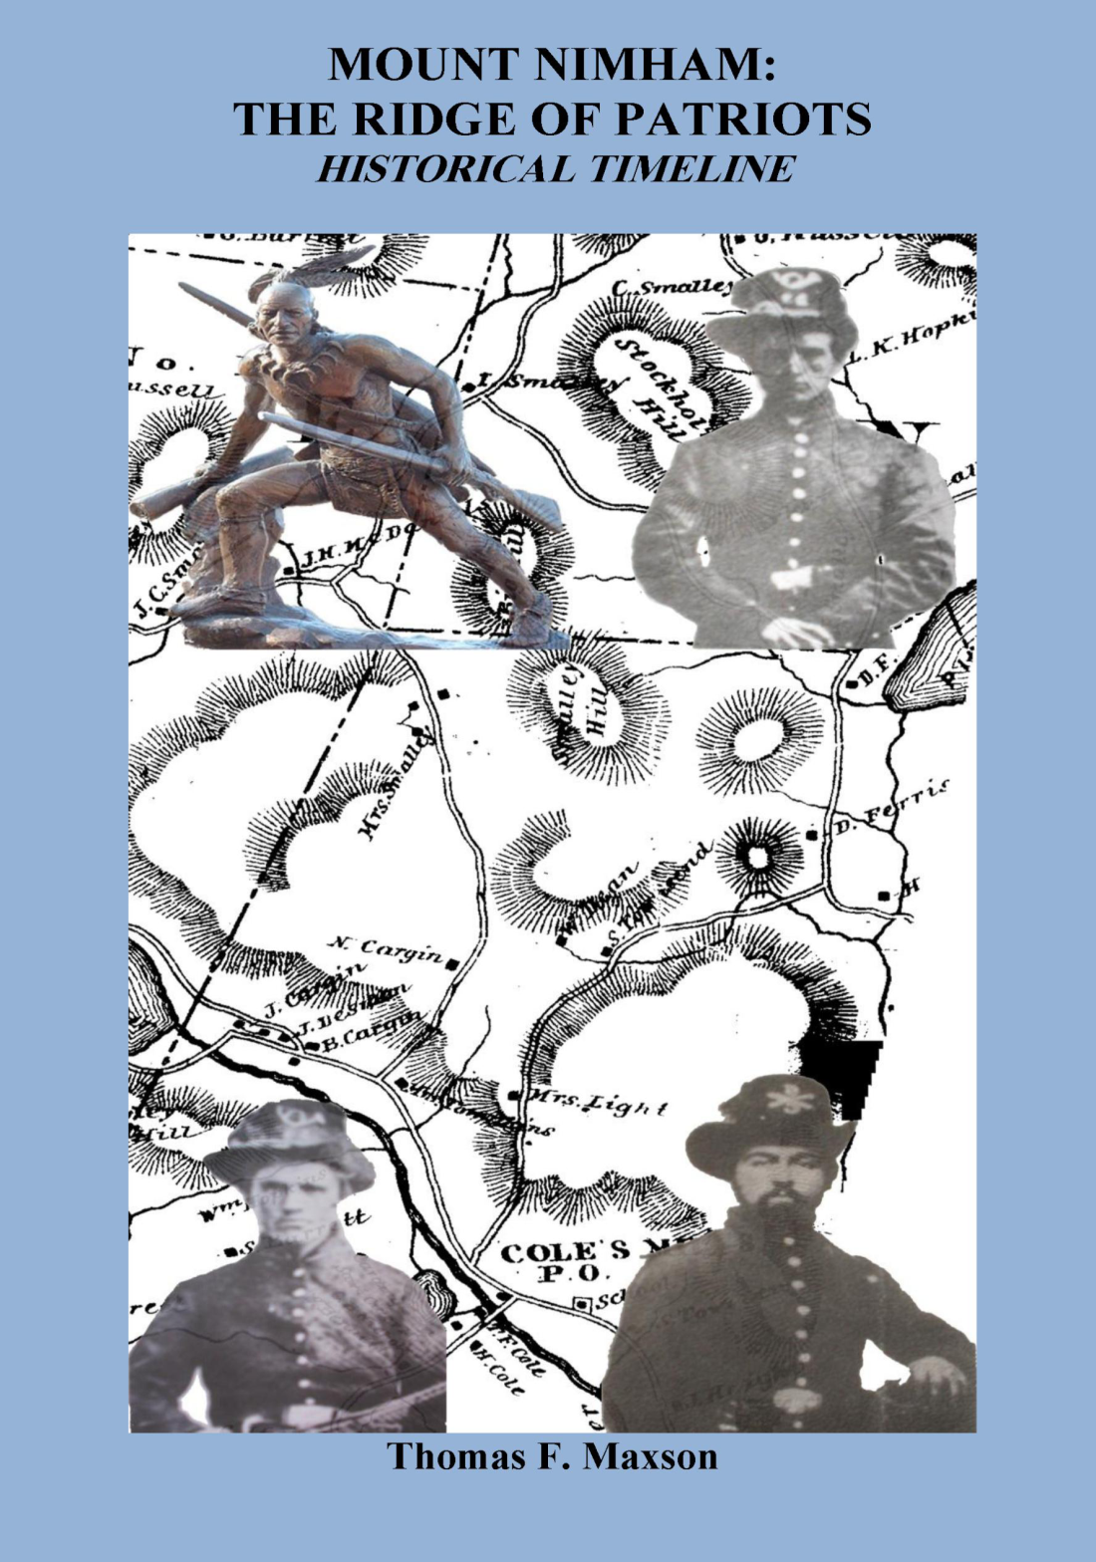
Please join the Kent Historical Society on Thursday, August 27, 2009 at 7:30 p.m. at the Old Town Hall at 770 Route 52 (following a brief business meeting) as Tom Maxson, author and Chairman of Highlands Preservation, Inc., and a member of the Kent Historical Society, recounts the history of the mountain which bears the name of the last Sachem of the Wappinger people, the true unsung American hero and patriot, Chief Daniel Nimham. Learn of the struggle of the great Sachem and his people to retain their ancestral homeland, and of the supreme sacrifice made for our enduring freedom. Also learn of the many other patriots who have lived, loved, and died on and around the mountain that bears his name. Familiar names, such as Smalley, Townsend, Russell, Cole, Hopkins, Hawkins, Light, Dean, and others, also live on in the grateful hearts and minds of the people of Kent for their patriotism and devotion to our town through the years. Follow their stories over the decades, as the mountain has been transformed from a farming and mining community in years past, to a spiritual and recreational mecca today.

Following the presentation, Tom will be available to sign copies of his book, with the author’s portion of the proceeds ($5.00 per book) being donated to the Chief Daniel Nimham Statue Fund. Light refreshments will be served.

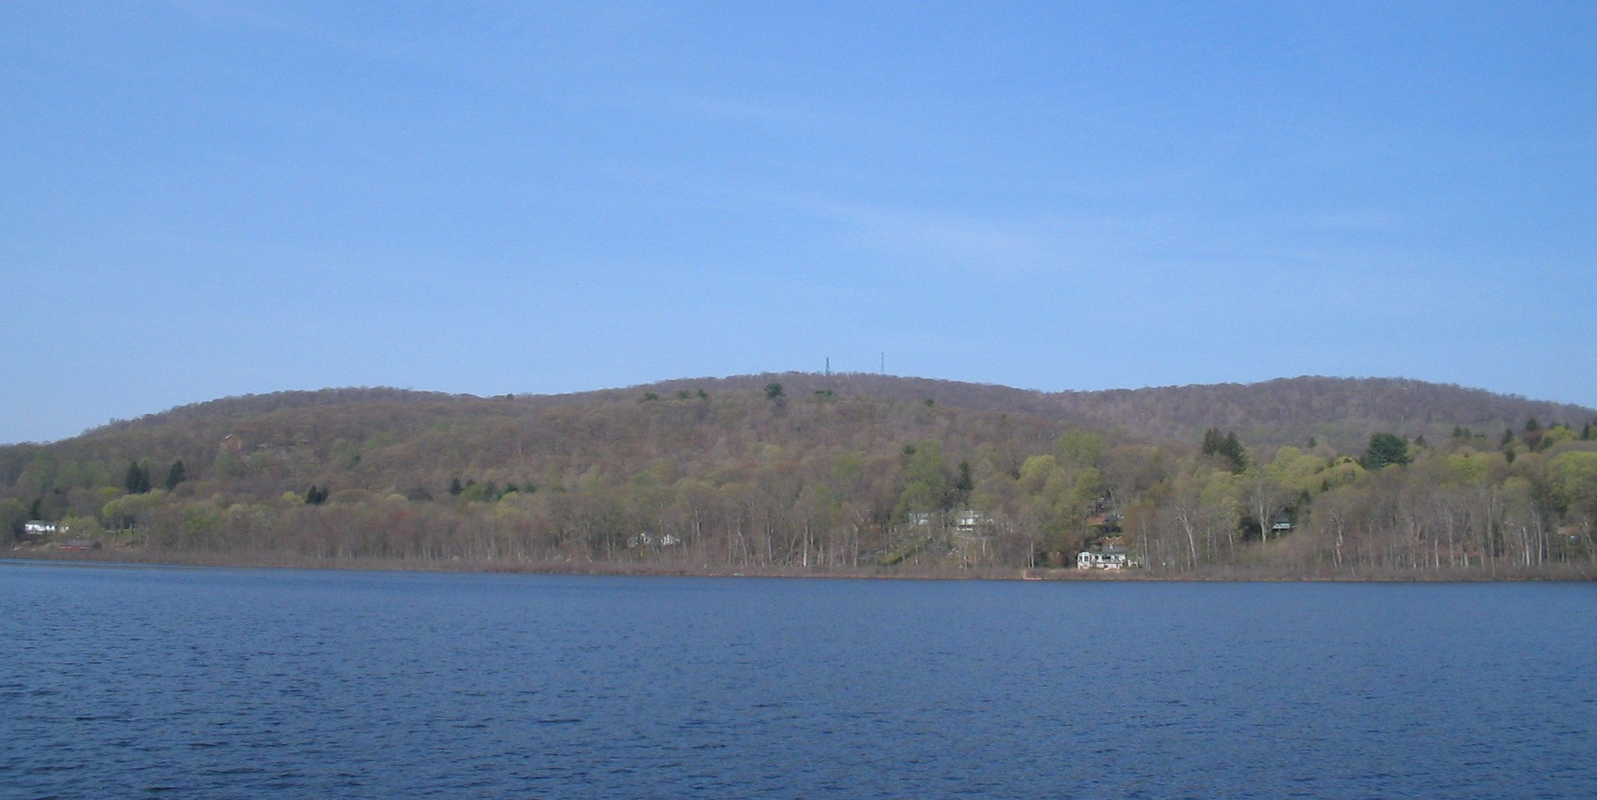
“A person who stands on the high land in Carmel, south of Lake Gleneida, sees far to the northwest, three lofty mountains that tower above all the country round. To the middle peak, which is the highest, we have given the name of the last Sachem of the tribe that once ruled all the lands that can be seen from its highest summit: and we trust that in honor of his valor, and of the faith sealed with his blood, on the field where he fought for the liberty of America, it will bear to all future time the name of Mount Nimham.” William S. Pelletreau

